Topic: Stepwise Refinement Approach
Tripti Vishwakarma
Colorado State University Global
Course Code: CSC 505-1
Jonathan Vanover
June 23 2024

Stepwise refinement is a method of breaking down the process of writing a program into smaller, more manageable steps. Each step refines the program's functionality until the final solution is reached. Below are three levels of procedural abstractions for a check writer program that converts a numeric dollar amount into words.

Level 1: Basic Algorithm
- Input:
  - Prompt the user to enter a numeric dollar amount (float).
- Validation:
  - Check if the input amount is valid (non-negative float).
- Conversion to Words:
  - Convert the dollar amount into words (e.g., 1234.56 -> "One Thousand Two Hundred Thirty-Four Dollars and Fifty-Six Cents").
- Output:
  - Print the amount in words.

Level 2: Procedural Abstraction
Expand each step into more detailed functions:
- Input Function:
  - Function to handle user input validation and conversion from string to float.
- Validation Function:
  - Function to validate the input amount (non-negative float).
- Conversion Functions:
  - Main Conversion Function: Orchestrates the conversion process.
  - Integer Conversion: Converts the integer part of the amount into words.
  - Decimal Conversion: Converts the decimal part of the amount into words.
  - Formatting Function: Combines integer and decimal parts into a single formatted string.
- Output Function:
  - Function to handle output (printing to console).

Level 3: Detailed Implementation
Further decompose conversion steps:
- Input Handling:
  - Validate user input format and handle exceptions.
- Validation:
  - Implement specific checks for non-negative float validation.
- Conversion to Words:
  - Integer Conversion:
    - Handle thousands, millions, etc., using a loop or recursive function.
  - Decimal Conversion:
    - Convert cents and append "Cents" if necessary.
  - Formatting:
    - Handle edge cases (e.g., "One Dollar" vs. "Two Dollars", pluralization).
- Output:
  - Ensure the output is formatted correctly with the correct grammar and punctuation.

UML Diagram:

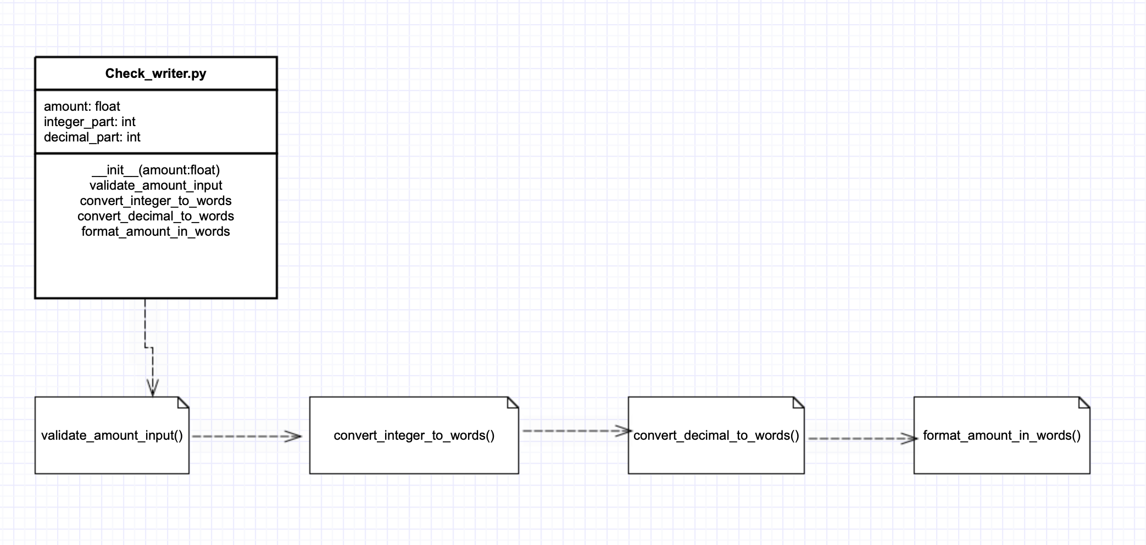

Python Script:

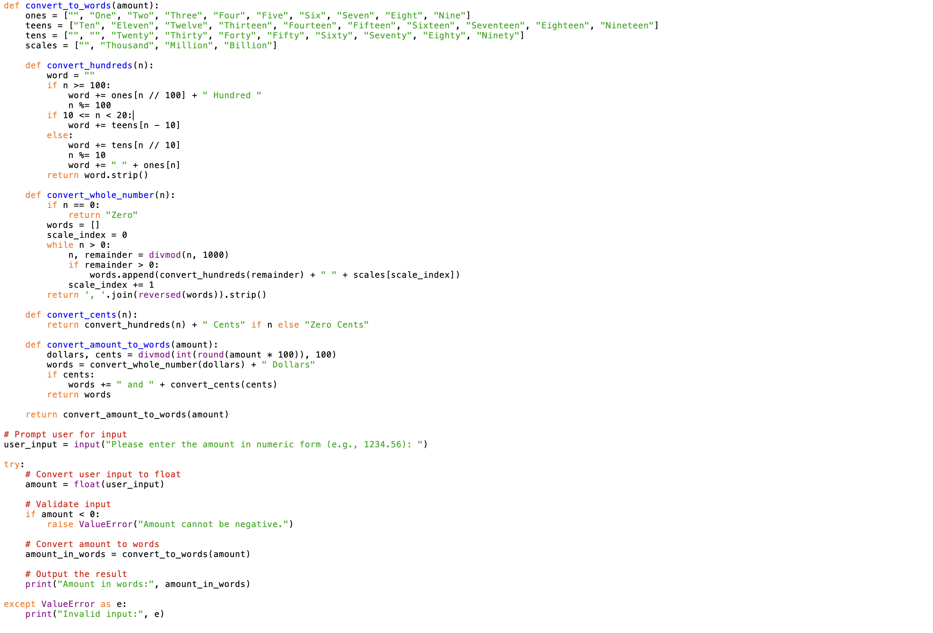

Execution:

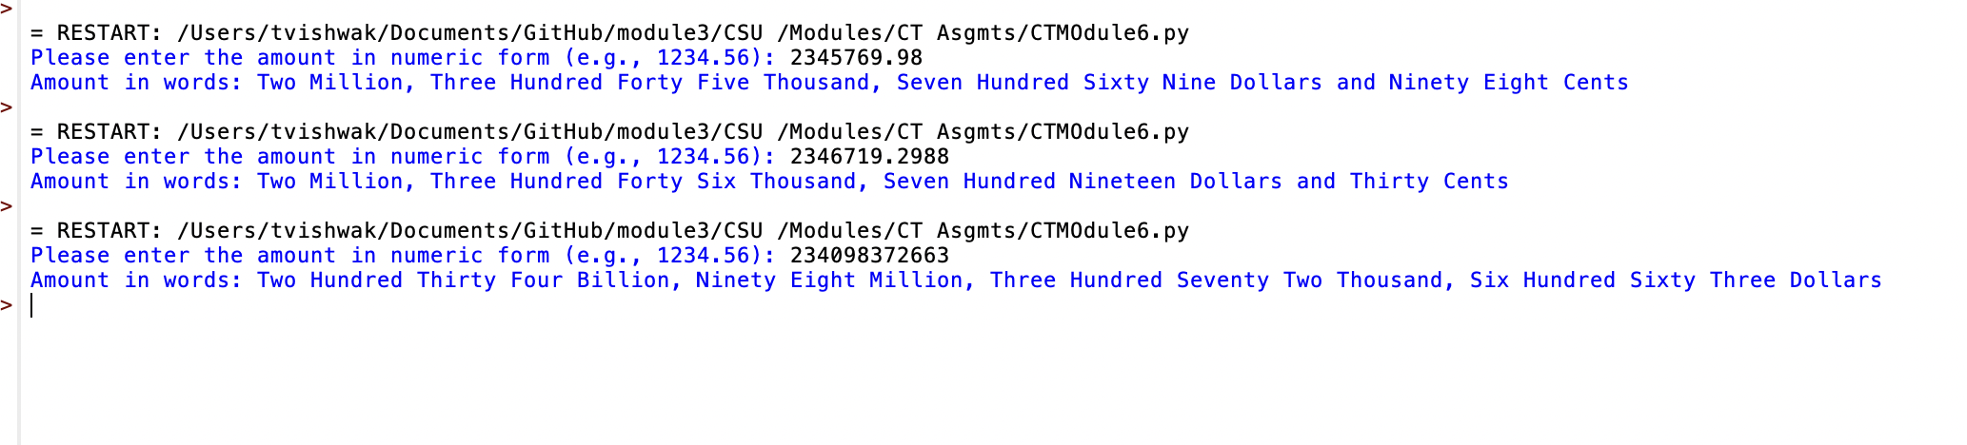

References:

Software Designs Basics- https://www.tutorialspoint.com/software_engineering/software_design_basics.htm

"Software Engineering: A Practitioner's Approach" by Roger S. Pressman (7th edition, 2010)
https://platform.virdocs.com/read/1490446/200/#/4/4

